FAQs
What is the Local Transport Plan
The Local Transport Act 2008 requires the LCRCA, as the local transport authority, to produce a Local Transport Plan (LTP) as a statutory requirement (we have to do one). The legislation requires that LTPS contain policies and implementation plans for the delivery of their policies. With a clear vision, ambition and goals, the proposed Local Transport Plan provides a strategic blueprint to 2040 and beyond for making the transport network safer, more integrated. More attractive, sustainable, inclusive and accessible to all- which are the key pillars of Liverpool City Region Mayor Steve Rotherham’s vision for a London style transport system but bigger and better.
The LTP is a statutory document with clear vision and goals, and a purpose of continuing to support communities and improving transport for everyone, aligning with wider CA ambitions.
What are its Vision and Goals:
The vision of the plan is:
“Clean, safe and accessible transport for moving people and goods.”
GOAL 1: Support good, clean job growth and opportunity for all.
Make sure transport supports local growth. This means equal opportunities for all to access affordable transport systems that connect people to jobs and services – all while keeping the environment in mind.
GOAL 2: Achieve net-zero carbon and an improved environment.
Reach net-zero carbon emissions by 2035, whilst protecting and improving our local environment.
GOAL 3: Improve health and quality of life. Improve health and quality of life.
Improve the health and quality of life for our people and communities. Make sure transport is safe, clean and good for the environment around us.
GOAL 4: Transport that’s well maintained and resilient.
Make sure our transport network and assets are well maintained, long lasting, and tough to the effects of climate change.
GOAL 5: Plan and respond to uncertainty and change and be innovative.
Become a forward-thinking region. Use innovation and new technologies, plan for uncertainty and change, and improve future travel in the region.

What is a draft Delivery Plan?
The draft Delivery Plan sets out how we will deliver the goals, principles, policies and priorities set out in the Local Transport Plan. The delivery plan identifies funding opportunities, and proposals.
Where does the funding for the draft Delivery Plan come from?
There are three funding phases in the draft Delivery Plan 2025 to 2040
- Current programme – until March 2027
- Imminent phase - April 2027 to March 2032
- Future vision- April 2032 to March 2040
The funding for the Current programme is fully committed with many schemes already well under way.
The funding for the Imminent phase will largely be delivered using our £1.6 billion Transport for City Regions (TCR) funding from central government.
The Future vision is less well defined at the moment. Further work such as feasibility studies and further design work will need to be undertaken. The feasibility studies will check if the proposed schemes are practical and likely to work.
What happens next after the draft Delivery Plan consultation in January/February 2026?
The feedback from the survey will provide us with useful information which will help shape future schemes and projects as they go on to get developed and designed in more detail.
When will the Final LCR Local Transport Policy Document and Delivery Plan be published?
After reviewing consultation feedback, we will make any necessary amendments to the documents and prepare them for adoption and publication in Spring 2026.
Once published, the final version will form part of the statutory policy framework for the Liverpool City Region.

Background Information
The Local Transport Plan Consultation Autumn 2024
In the Autumn of 2024, we consulted with citizens and stakeholders on the draft Local Transport Plan (LTP). We wanted to find out what you liked, what would encourage you to walk and cycle more and what would make you leave the car at home and use public transport more to make sure we create a transport system that works for everyone.
How the consultation shaped the Local Transport Plan
We had a good response to the consultation with over 1,000 citizens providing feedback.
Your feedback helped us improve the Local Transport Plan, so its goals and messages are clearer for everyone.
The plan focuses on people, placemaking and decarbonisation, supporting a major shift to sustainable transport while supporting city region priorities such as housing, economic growth (aligned with the LCR Growth Plan), health, inclusion and spatial planning priorities.
The level of support for each policy can be seen below.
- The table below provides a summary of responses to the 21 draft policies in the LTP. Those with the highest scores, shown in green, are where people have indicated “support” or “strong support”.
- All policies enjoy good levels of support.
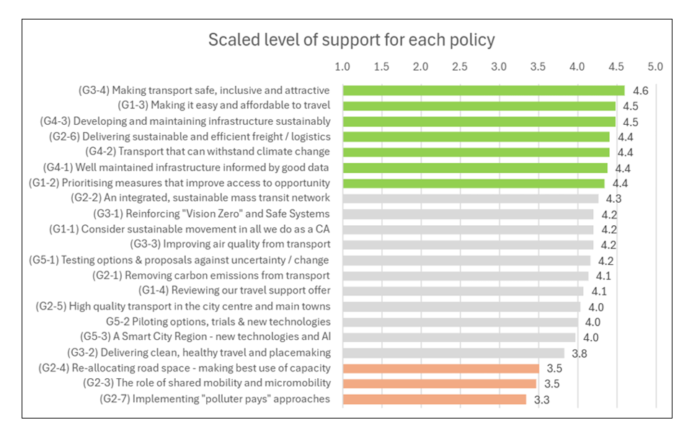
- "Making transport safe, inclusive, attractive and reassuring for the user” is the draft policy that has the highest degree of support. The policies with lower scores are shown in amber.

What did we change as a result of the Consultation?
- The 5 goals, 8 principles and 21 policies of the plan remain the same but have all been refined and updated.
- Safety” has been added as an explicit part of Goal 3 (health and wellbeing). Making transport safe has been a big, consistent theme through the consultation. The language has been strengthened throughout to recognise this. Transport must be safe, and perceived to be safe, to achieve the goals in the LTP
- The policies relating to the importance of a more liveable, more sustainable and better-connected city centre have been refined. These now also refer to other towns and main centres across the LCR, as main generators of trips and movement.
- Planning for coaches (not just buses) has been added. Consultees recommended reference to planning for coaches as it links to the importance of coach travel in supporting the LCR’s visitor economy.
- Port and freight references now reflect the cancellation of the A5036 Port of Liverpool scheme in the 2024 Budget. However, addressing the problems in the corridor and the wider area remains a priority for the plan.
- The resilience themes in the plan under Goal 4 highlight the importance of “making best use” of assets and adapting to a changing climate.
- The plan strengthens references to the Mayor and the LCRCA’s water management work, whereby reducing run-off from roads and hard standings is one of the big transport challenges.

